Questions and answers (young people)
- Who can apply for summertime work practice in Helsingborg?
Anyone born between 2004-2008 who is registered in the municipal area can apply for summer work practice, 2024.
- When and how do I apply?
You can apply for work practice between the 5 February and the 3 March 2024. You apply via a link on the website www.helsingborg.se/sommarpraktik. Only those who apply during this period will be considered for work practice.
- Who is eligible for summer work practice?
The City of Helsingborg provides summer work practice for young residents between 16 and 20 years of age. Usually over 2100 applications are received. However, there are not enough vacancies for all who apply and so not all applicants can be offered a place. We give priority to those who have applied previously but were not offered a place. The more sectors and time periods you apply for, the greater your chances are of getting a work practice placement.
Once the application period is over, we start matching the applications with suitable work practice vacancies. Write as much as you can about yourself and your interests as this will increase your chances of getting the job you want.
4. What is school-holiday work practice?
School-holiday work practice is available to young people between 13 and 15 years of age. School-holiday work practice should not be confused with summer work practice and any applications you have submitted for school-holiday work practice will not be counted as applications for summer work practice. You can find out more about school-holiday work practice here https://helsingborg.se/arbete/for-dig-som-ung/ar-du-mellan-13-och-15-ar-och-vill-jobba-under-skollovet/.
5. When will I know that I have been accepted for work practice?
Applicants will receive an email on the 26 March 2024 where they will be requested to log in to “My pages” (Mina sidor) at helsingborg.se/sommarpraktik. Under ”My pages” you will be able to see whether or not you have been accepted for summer work practice and which work practice placement you have been offered. Under ”My pages” you click on either “Yes, I accept this placement“ (Ja tack, jag vill ha denna plats) or ”No thanks, I do not want this placement” (Nej tack, jag vill inte ha denna plats). If you click on ”No thanks” you will not be offered another placement this year. You must reply no later than the 8 April 2024. If you have not clicked on either of the alternatives by the 8 April, you will lose the placement you have been offered.
If you accept the offer of a placement you must request a criminal record check from the police (”Utdrag från polisens belastningsregister”) and send it to us in the postage paid envelope that will be sent to you, or send it to:
Helsingborgs stad
Arbetsmarknadsförvaltningen
Näringsliv- och matchningsenheten
Sommarpraktik
25189 Helsingborg
The criminal record check must be received by our office no later than 10 May 2024. If it is not received in time or there is an entry in the record, then you may lose your work practice placement.
6. How do I accept/decline an offer of work practice?
Go to helsingborg.se/sommarpraktik and under ”My pages” click on either “Yes, I accept this placement“ (Ja tack, jag vill ha denna plats) or ”No thanks, I do not want this placement” (Nej tack, jag vill inte ha denna plats). You must reply no later than the 8 April 2024. If you click on ”No thanks” you will not be offered a new placement this year. If you have not clicked on one of the alternatives by the 8 April, you will lose the placement you have been offered.
Once you have confirmed your interest in the work practice offer you must digitally sign your work practice agreement. You use the same log-in information for logging in to ‘My pages’ to sign the agreement. Please note that we do not send you the agreement by post. You must sign your agreement no later than the 8 April 2024. The agreement will only be valid if you have submitted a criminal record check from the police (”Utdrag från polisens belastningsregister”) in good time, and there is no entry in the records.
7. Do I have to request a criminal record check from the police?
If you want to be accepted for work practice with ”Children and young people”(Barn och unga), ”Care and nursing” (Vård och omsorg), Kitchen work (kök) or ”Clubs and leisure time activities” (Förening och fritid) you have to request a criminal record check from the police. It is obligatory. You may even have to submit a criminal record check if you are offered a placement in one of the other sectors. For example, if you have applied for “Gardens and maintenance” (Trädgård och fastighet) it could mean you will do your work practice at a school and then you are required to have a criminal record check for “Schools and child care”.
You must submit the criminal record check at the same time as you accept a placement. If it is not received by the 10 May 2023 or there is an entry in the records, then you may lose your work practice placement. The criminal record check from the police (not the request for the record check) is to be sent to address below in the pre-paid envelope provided.
Helsingborgs stad
Arbetsmarknadsförvaltningen
Näringsliv- och matchningsenheten
”Sommarpraktik”
25189 Helsingborg.
You must apply for the criminal record check from the police yourself. You should do this at the same time you apply for work practice. It can take about two weeks before you receive the criminal record check so make sure you do this in good time.
If you apply for work practice in several sectors that each require a criminal record check, you must apply for a criminal record check separately for each one. You cannot, for example, use a record check for ”Children and young people” for a placement with ”Care and nursing”.
The simplest way to request a criminal record check is to go to www.polisen.se. Choose ‘Belastningsregistret’ from the menu on the left.

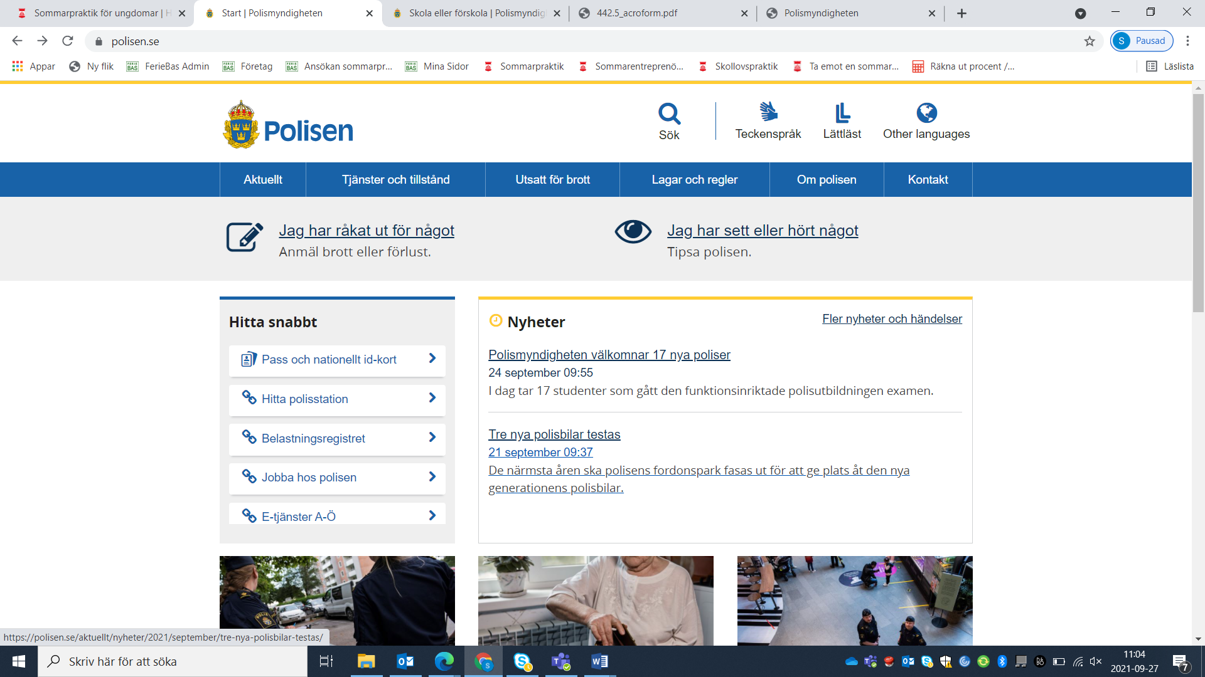

Then click on ”Till e-tjänst för registerutdrag”:
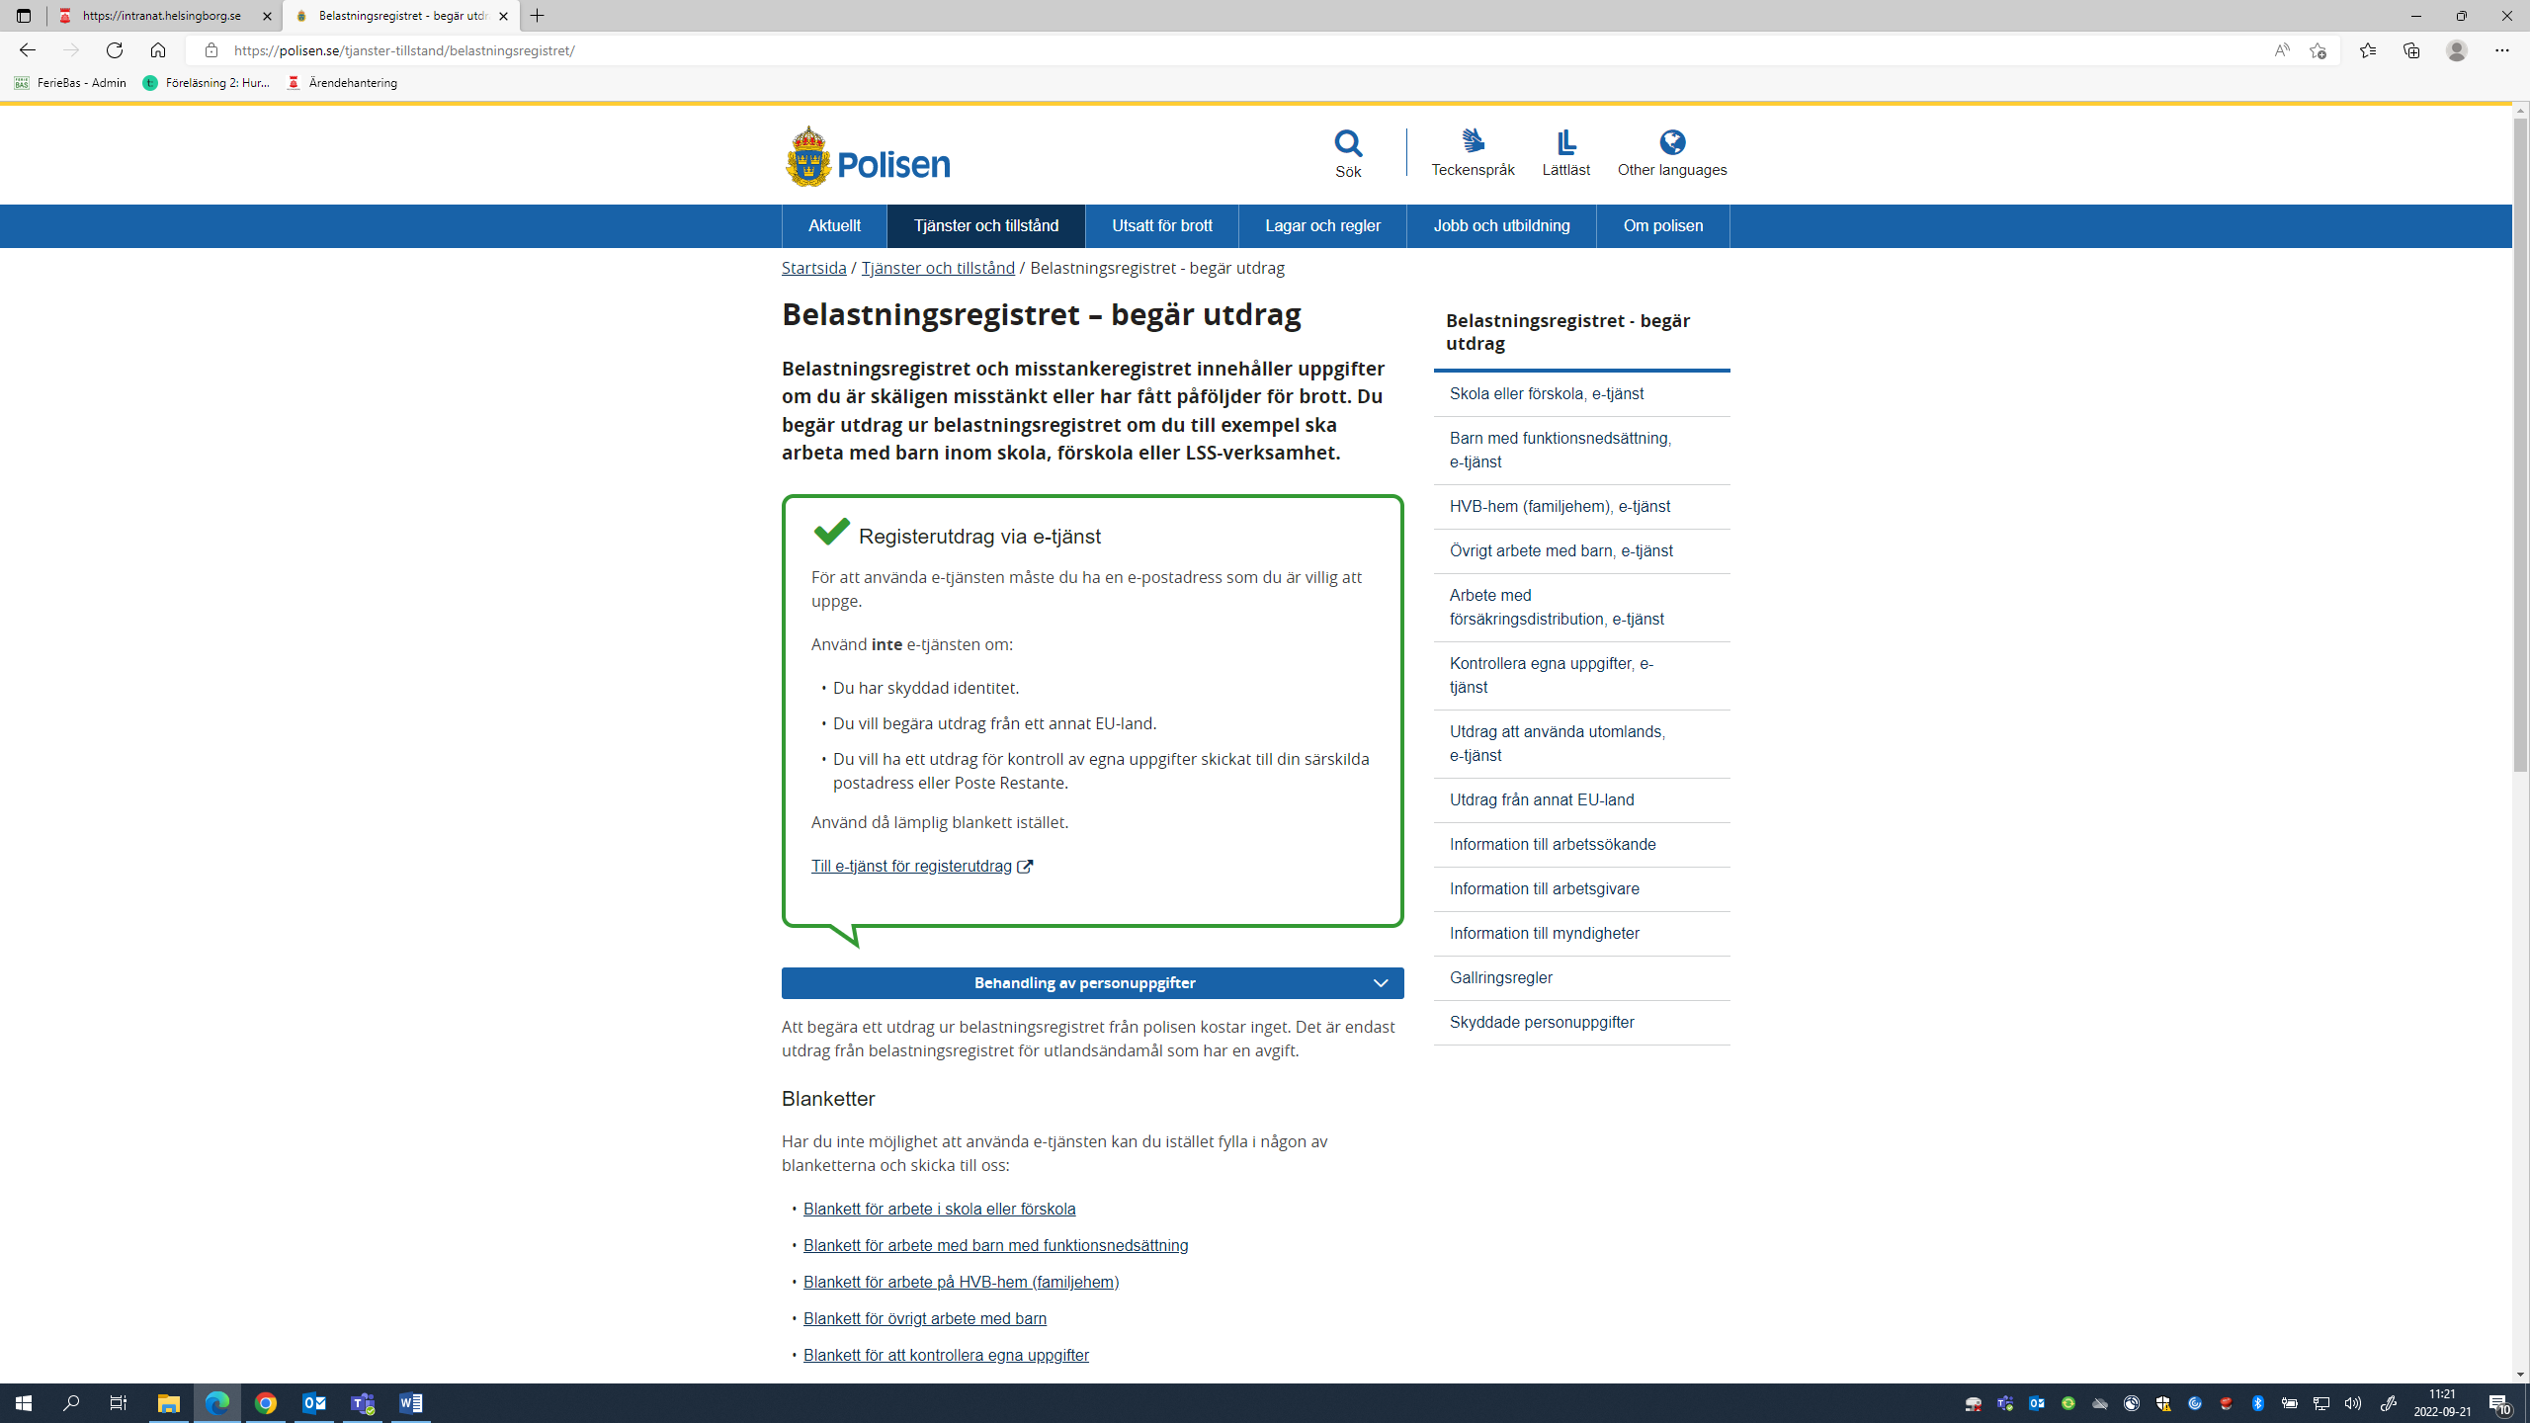

Choose a method of identification to log in to their electronic services (e-tjänst):
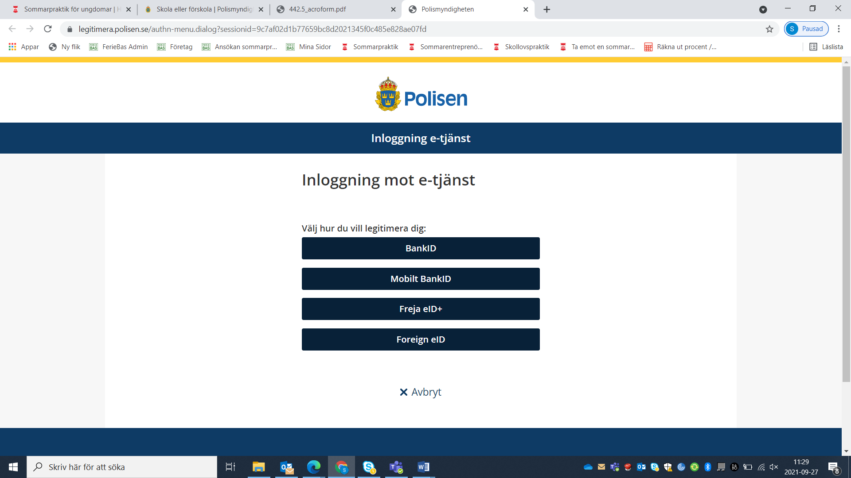
Follow the steps to log in. After this choose ‘registerutdrag’ in the pull-down menu and enter your contact information. Click on next (nästa) at the bottom of the page, read through your details and click send (skicka)
There are numerous record checks available so be careful to choose the right one(s).
Choose ”Arbete inom skola eller förskola” for work practice at Schools and Child Care, or “Trädgård och fastighet” for Maintenance and gardens at Schools/Child Care.
Choose ”Kontroll av egna uppgifter i belastningsregistret” for work practice at Nursing and Care facilities.
Choose ”Arbete med barn i annan verksamhet än skola och barnomsorg” for work practice with club activities for children.
Choose ”Arbete inom skola och förskola” for work practice in kitchens at Schools/Child Care.
Choose ”Kontroll av egna uplifter i belastningsregistret” for work practice in kitchens at care homes for the elderly
Choose ”Kontroll av egna uppgifter i belastningsregistret” for work practice within the Labour Market Administration (Arbetsmarknadsförvaltningen). This sector includes Summer Entrepreneurship and Culture & Administration.
Please note that the criminal record check (not your request form) for “care of the elderly” and “care-home kitchen work”, as well as work practice within the Labour Market Administration, must be submitted unopened.
If you cannot identify yourself electronically, look below the picture on how to apply for record checks via the electronic service on the same page. Here you will find the forms needed to request record checks - ”Begäran om utdrag”

Choose ”Skola eller förskola” for work practice in Schools/Child Care, kitchens at Schools/Child Care or Maintenance and gardens at Schools and Child Care.
Choose ”Övrigt arbete med barn” for work practice in club activities for children..
Choose ”Kontrollera egna uppgifter” for work practice at care homes or in kitchens at care homes for the elderly or the Labour Market Administration (Arbetsmarknadsförvaltningen), for Summer Entrepreneurship and Culture & Administration.
Please note that the criminal record check (not your request form) for “care of the elderly” and “care-home kitchen work” must be submitted unopened.

8. How do I request a criminal record check from the Police?
You must apply for the criminal record check from the police yourself. You should do this at the same time you apply for work practice. It can take about two weeks for the police to process your request from the time they receive your request to when they send it. When they have many requests to deal with the processing time can be longer, so make sure you apply in good time.
Please note that the police are unable to fast track or give priority to individual requests.
Criminal record checks for use in Sweden are sent by B-post (3-5 working days)
If you apply for work practice in several sectors that each require a criminal record check you must apply for each sector separately. You cannot, for example, use a record check for ”Children and young people” for a placement with ”Care and nursing”.
The simplest way to request a criminal record check is to go to www.polisen.se. Choose ‘Belastningsregistret’ from the menu on the left.

Then click on ‘Electronic services for criminal record checks’ ”Till e-tjänst för registerutdrag”:
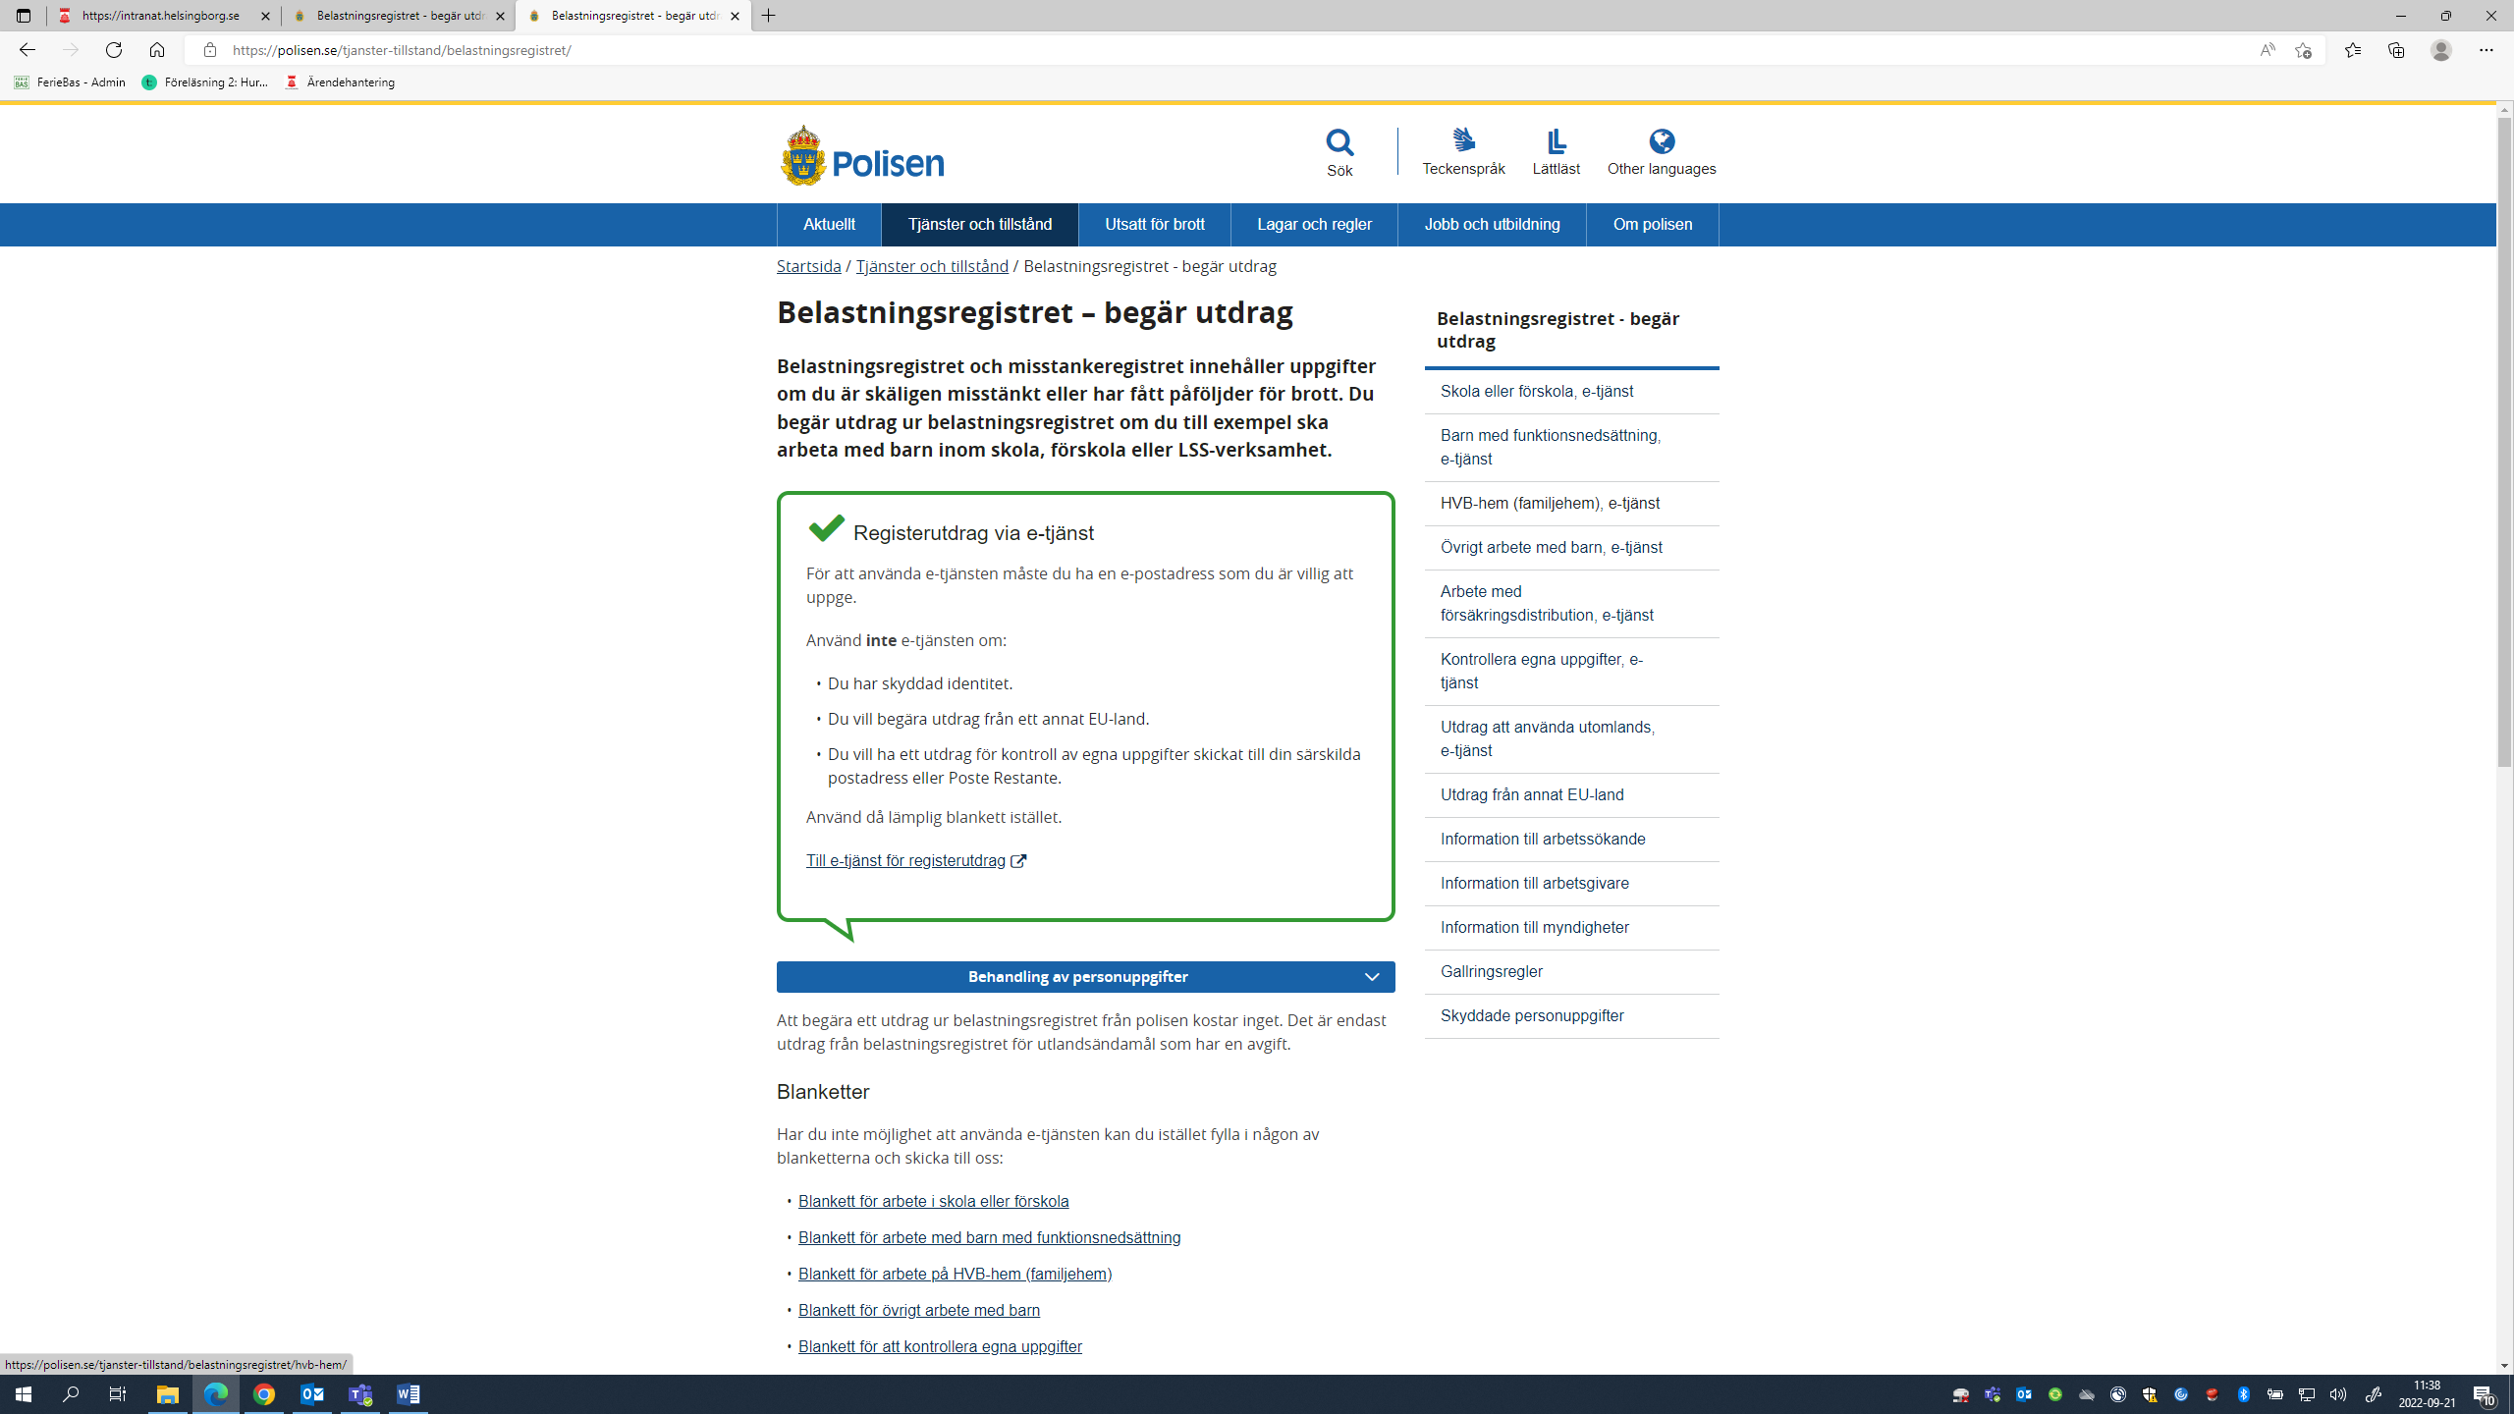

Choose a method of identification to log in to their electronic services (e-tjänst):

Follow the steps to log in. After this choose ‘registerutdrag’ in the pull-down menu and enter your contact information. Click on next ‘nästa’ at the bottom of the page, read through your details and click send ‘skicka’.
There are numerous record checks available so be careful to choose the right one(s).
Choose ”Arbete inom skola eller förskola” for work practice at Schools/Child Care, or Maintenance and Gardens at Schools/Child Care.
Choose ”Kontroll av egna uppgifter i belastningsregistret” for work practice at Nursing and Care facilities.
Choose ”Arbete med barn i annan verksamhet än skola och barnomsorg” for work practice in club activities for children.
Choose ”Arbete inom skola och förskola” for work practice in kitchens at Schools/Child Care.
Choose ”Kontroll av egna uppgifter i belastningsregistret” for work practice in kitchens at care homes for the elderly
Choose ”Kontrollera egna uppgifter” for the Labour Market Administration (Arbetsmarknadsförvaltningen), for Summer Entrepreneurship and Culture & Administration.
Please note that the criminal record check (not your request form) for “care of the elderly” and “care-home kitchen work” as well as for the Labour Market Administration, must be submitted unopened.

If you cannot identify yourself electronically, look below the illustration on how to request a record check electronically. There you will find the forms needed to request record checks - ”Begäran om utdrag”

Choose ”Skola eller förskola” for work practice at schools/preschools, in the kitchens at schools/preschools or maintenance and gardens at schools/preschools.
Choose”Övrigt arbete med barn” for work practice in club activities for children.
Choose ”Kontrollera egna uppgifter” for work practice at care homes or in kitchens at care homes for the elderly or the Labour Market Administration (Arbetsmarknadsförvaltningen), for Summer Entrepreneurship and Culture & Administration.
Complete the chosen form(s), print and sign.
This is how you submit requests for criminal record checks from the police:
Scan or photograph all your documents and enclose them as a pdf-, jpeg- or tiff-file, max 2 Mb in size. The police cannot open files that are linked to the Internet or similar.
E-mail: registerutdrag@polisen.se
Alternatively, you can send your request by post (you will need a stamp)
Polismyndigheten
Box 757
981 27 Kiruna
Please note that the criminal record check (not your request form) for “care of the elderly” and “care-home kitchen work” as well as for the Labour Market Administration, must be submitted unopened.

9. How does ”My pages” (Mina sidor) work?
Once you have applied for work practice a link to My Pages (Mina sidor) will be sent to your email address. Click on the link and follow the instructions to create your own password. You can log in to ”My pages” using your personal ID (personnummer) and password. “My pages” shows information about your application and lets you change your contact information at any time, for example if you move, change your mobile number or email address. If you wish to change any of your choices or the periods you can work you can also do this under ”My pages” but only if the application time has not expired, that is, until the 3 March 2024.
10. Within which sectors is work practice offered?
Work practice is offered within the following sectors:
Children and young people: Do you set a good example and like playing with children and finding things to do? In this sector you will be looking after children at, for example, pre-school, leisure activity centres or day camps. You might be helping with meals, games and activities. You will require a criminal record check.
Clubs and leisure time activities: Are you interested in sport, riding or other leisure time activities? Are you a good leader? There are work practice opportunities within different clubs, societies and events where you can assist by being a leader for a group of children, carry out simple office duties or manage premises or outdoor facilities. This sector also requires a criminal record check.
Culture and administration: Are you interested in the theatre, music, Culture or administrative duties? There are work practice opportunities in a variety of areas concerned with cultural activities and administration. This could be at a museum, a library, a records department or an office. Your duties could be simple office work, filing, acting or playing music or helping to organise different cultural events. Some placements require a criminal record check. Note that the envelope containing the criminal record check must be submitted unopened.
Summer enterpreneurship: Are you interested in society and labour-market issues? Are you curious to learn more about Entrepreneurship? Can you work with others and are you sociable? Work practice duties can involve helping with various tasks, like carrying out surveys or interviewing local residents. This requires a criminal record check. Note that the envelope containing the criminal record check must be submitted unopened.
Gardens and buildings: Are you a practical person? Then this sector could be something for you. Here there are placements in caretaking, cleaning and gardening. Examples of work practice outdoor duties include painting, mowing lawns, tidying and weeding borders. These duties could also require a criminal record check if they involve caretaking duties at a school/pre-school.
Care and nursing: Do you like working with people? There are work practice opportunities in care of the elderly for example, or helping the functionally challenged. You may have to help at mealtimes or with activities like reading or going for a walk. A criminal record check is required. Note that the envelope containing the criminal record check must be submitted unopened.
Kitchen duties at a school, child care facility or care home: Are you interested in cooking? Are you studying to be a chef or about to start? Here you will get the opportunity to work in a kitchen at a school or care home. Criminal record checks are required for schools and care homes. Please note that a separate record check is required for each category.
Criminal record check for kitchen duties at a school/child care: Click here to apply for a criminal record check.
Criminal record check for kitchen duties at a care/nursing facility: Click here to apply for a criminal record check. NB The envelope containing this criminal record check must be submitted unopened!
Please note that there are different criminal record checks for each work practice sector. You cannot, for example, use a record check intended for “Children and young people” for a placement within “Care and nursing”. Note that the envelope containing the criminal record check for a care facility, or a care facility kitchen, should not be opened.
Please note: If you do not submit the correct record check by the 10 May 2024 or if your record check has an entry, the City of Helsingborg has the right to retract any placement that has been offered and your work place agreement will become invalidated.
11. What are the time periods for work practice?
Period 1 is the 10 June – 28 June (weeks 24, 25 and 26)
Period 2 is the 1 July – 19 July (weeks 27, 28 and 29)
Period 3 is the 22 July - 9 August (weeks 30, 31 and 32)
Make sure you have not planned a holiday, summer school or similar activity this summer that would prevent you from accepting a work placement. You must be able to work for the whole period you have been offered. Once you have been offered work practice you cannot change the time period later.
12. May I work more than one period?
No, because as many young people as possible must be given the chance of getting a placement, only one period is permitted. If you state that you can take work practice during any of the periods, you stand a greater chance of getting a placement.
13. May I work more than 90 hours?
No, considering that so many young people as possible should be offered work practice, payment is made for a maximum of 90 hours only. During the three-week period you work 90 hours made up of daytime hours, Monday to Friday, for a maximum of 8 hours a day. The work practice is set at 90 hours and you cannot get paid for more. If your schedule is unclear and can be misread so it seems your practice exceeds 90 hours, then you must contact your supervisor so he/she can correct it. Lunch breaks and time off are unpaid.
In the first time period you work just over 6 hours a day as you are free on Midsummer’s Eve. Hours for Midsummer’s Eve are then spread out through the remainder of the period. In the second and third periods you work 6 hours a day.
If you are under 18 (in accordance with AFS 2012:3 The work environment for minors (Minderårigas arbetsmiljö) ) you may not have any other occupation like a practice placement, work or education that would result in you exceeding a 40-hour working week. You can find out more about what applies to young people here.
14. What are the work practice hours?
For the three-week period you will be working for a maximum of 8 hours a day, Monday to Friday, up to a maximum of 90 hours spread out evenly over the three week period. You must take a continuous break of at least 30 minutes. The work practice hours may vary slightly, but most work between 08.00-15.30 with a half-hour lunch break. The lunch break is unpaid.
Period 1 = 14 days = just over 6 hours/day = 90 hours in total
Period 2 = 15 days = 6 hours/day = 90 hours in total
Period 3 = 15 days = 6 hours/day = 90 hours in total
You must not work unsocial working hours, for example, before 7.00 a.m. or after 6 p.m. You may not work at the weekends, in the evenings or nights.
If you miss a day, because of illness for example, you can discuss with your place of work the possibility of making up the time as long as it is within the work practice period. You can prolong certain days up to 8 hours. You may not work Midsummer’s Eve. You can find out more about what applies to young people here.
15. What rules apply on Midsummer’s Eve?
No work practice is allowed on this day. You have this day off.
16. Can I change my placement if I am not satisfied with it?
No, we try as far as possible to match the information you provided in your application with a suitable work practice. If for any reason you wish to decline your assigned work practice, get in touch with us as soon as possible so that someone else can be given it instead.
17. Can I get work practice with a friend?
No, you cannot. Summer work practice is a paid practice where you are expected to be able to carry it out on your own. If you don’t feel ready to take on a work practice without a friend, we advise you to wait before applying.

18. Corona/Covid 19
- Can my work practice be cancelled?
Your work practice can be cancelled at short notice if your workplace has an outbreak of Corona/Covid-19.
- What happens if my work practice is cancelled?
If your work practice is cancelled, we will try to find you a new placement. If you choose to decline this offer you will not be offered a new placement this year.
- Will I receive payment if the work practice is cancelled before it has started?
If the work practice is cancelled and we are unable to find you a new placement, you will not receive any payment. Likewise you will not receive any payment if you say no to a placement.
- What happens if my work practice is cancelled once it has begun?
If you get ill, you will receive no payment from Helsingborgs stad. If staff at your place of work get ill with Corona/Covid-19 during you work practice and your work practice is cancelled, you will receive payment.
19. Can I join a reserve queue in case someone declines their work practice placement?
Yes. Every year there is a number of young people who get offered a work practice placement and decide to decline the offer. This means it is possible that we contact you and offer you the placement. In this case it is a good idea to have a criminal record check ready to send as we may contact you at short notice. There is no tour order, if a vacancy does arise, it is offered by email to everyone in the queue and allocated on a first come first served basis.
20. Do I have to pay income tax?
Most people who get work practice placements in Helsingborg do not need to pay tax on their earnings. In order to be exempt from tax you have to meet the demands set out by the tax authority:
- You estimate that your total income for 2024 will be less than the tax authority’s maximum earnings limit for 2024. The amount has not yet been confirmed. In 2023 it was 22208 kronor (including for example, holiday pay and money for meals).
- You are a student.
- You will be living in Sweden for the whole year.
If you meet these demands, you must indicate this at the same time you say yes to work practice and sign the agreement. Please note that this is done digitally and we do not send you the form ‘Certificate for payment of earnings exempt from income tax’ (Intyg för utbetalning av lön utan skatteavdrag).

If you wish to apply for a tax adjustment you can find more information here.

21. When and how is your work practice salary paid?
When your work practice period has ended your supervisor sends your time report to us. The City of Helsingborg has commissioned Swedbank to manage salary payments.
If you wish to have your salary paid to your bank account you have to register your account with Swedbank’s account register, no matter which bank you have. You must do this before the work practice period commences. If you are over 18 and have “e-legitimation” (Bank ID or Mobile Bank ID) you can go online to swedbank.se/kontoregister and register your account. If you have no “e-legitimation” or are under 18 then you must go to Swedbank in person and register your account. If you are under 18 you must be accompanied by a parent/carer. Please note that you must have your own bank account, you cannot, for example, use a parent’s account for your salary payments.
If you do not register an account with Swedbank, we will send a payment advice to you by post. It is therefore important that you have given the correct address in your application and that your name is clearly shown on your letter box. Remember that a charge is made when you cash in a pay advice and a valid Swedish identification document will be required. You can cash in your pay advice at Swedbank or selected shops. Some shops set a limit of 2000 kr when paying out cash, and this may be restricted by the amount of cash available at that shop. Find out more on Swedbank’s website.
Salary will be paid on the following days:
Period 1: 26 July
Period 2: 27 August
Period 3: 27 September
22. How much will I earn?
Work practice remuneration for 2024 has not yet been determined. Information about this will be updated as soon as possible. In 2023 it looked like this:
Those born between 2003-2005 received 94 kr per hour.
Those born between 2006-2007 received 82 kr per hour.
23. Can I have more than one work practice/summer job during the same period?
If you are under 18 you may not, in accordance with AFS 2012:3 “The work environment for minors” (Minderårigas arbetsmiljö), have any other occupation, such as work practice, work or education, that would mean exceeding the 40-hour working week. You can find out more about what applies to young people here.

24. Am I insured when doing work practice?
Yes, you are covered by the City of Helsingborg’s insurance scheme.
25. I have changed my mind, what do I do?
If, for example, you have applied for work practice within Care of the elderly but realise that you would rather work in another sector, you can quite simply log in to “My pages” and change both your choice of sector and time period, as long as the application time has not expired. If you move, change your mobile phone number or your email address you can change these details in “My pages” at any time.
If you have accepted a placement but are not able to participate, you must tell us as soon as possible by email sommarpraktik@helsingborg.se, or you can call us on 042-10 71 84.
25. Sickness or days off?
If you are ill during your practice period, it is vital that you inform your supervisor.
If you wish to be free during this period, the matter must be discussed with your supervisor. You cannot count on being able to make good the hours you have been away because of illness or leave. You receive no pay for time off or the hours you are sick.
26. Work practice certificate.
If you require a work practice certificate your supervisor can help you.
26. Questionnaire
At the end of your work practice you will receive a questionnaire by email. You are expected to reply. We use your answers to make sure everything has worked according to plan and to improve the recruitment process for next year. The questionnaire only takes a few minutes to answer.

